Practical - 2
DATABASE SYSTEMS LAB ASSIGNMENT REPORT
Course Title: Advanced Database Management Systems
Topic: Relational Schema Design, Integrity Constraints, and Advanced SQL Queries

1. Executive Summary & Design Overview
This report demonstrates a production-grade relational schema implementing comprehensive integrity constraints. The target architecture maps an enterprise order-fulfillment system spanning 14 tables.
Core Architecture Metrics
- Total Component Tables: 14 structured entities.
- Minimum Table Width: Every table contains 8 or more verified attributes.
- Foreign Key Connectors: 15 explicit active relationships map data flow across dependencies.

2. Relational Schema Blueprint (DDL Script)
-- ==========================================
-- 1. DROP TABLES (For clean re-runs)
-- ==========================================
DROP TABLE IF EXISTS Inventory;
DROP TABLE IF EXISTS Warehouses;
DROP TABLE IF EXISTS ReviewComments;
DROP TABLE IF EXISTS OrderDetails;
DROP TABLE IF EXISTS Shipments;
DROP TABLE IF EXISTS Payments;
DROP TABLE IF EXISTS Orders;
DROP TABLE IF EXISTS ProductSuppliers;
DROP TABLE IF EXISTS Products;
DROP TABLE IF EXISTS Categories;
DROP TABLE IF EXISTS Employees;
DROP TABLE IF EXISTS Departments;
DROP TABLE IF EXISTS Suppliers;
DROP TABLE IF EXISTS Customers;

-- ==========================================
-- 2. CREATE TABLES WITH CONSTRAINTS (8+ Attributes each)
-- ==========================================

CREATE TABLE Customers (
CustomerID INT PRIMARY KEY,
CustomerName VARCHAR(100) NOT NULL,
Email VARCHAR(100) UNIQUE NOT NULL,
Phone VARCHAR(20) NOT NULL,
Address VARCHAR(255) NOT NULL,
City VARCHAR(100) NOT NULL,
Country VARCHAR(100) DEFAULT 'India',
PostalCode VARCHAR(20) NOT NULL,
IsActive INT DEFAULT 1 CHECK (IsActive IN (0, 1))
);

CREATE TABLE Suppliers (
SupplierID INT PRIMARY KEY,
SupplierName VARCHAR(100) NOT NULL,
ContactName VARCHAR(100) NOT NULL,
Email VARCHAR(100) UNIQUE NOT NULL,
Phone VARCHAR(20) NOT NULL,
Address VARCHAR(255) NOT NULL,
City VARCHAR(100) NOT NULL,
Country VARCHAR(100) DEFAULT 'India',
SupplierStatus VARCHAR(20) DEFAULT 'Active' CHECK (SupplierStatus IN ('Active', 'Inactive'))
);

CREATE TABLE Departments (
DepartmentID INT PRIMARY KEY,
DepartmentName VARCHAR(100) UNIQUE NOT NULL,
ManagerName VARCHAR(100) NOT NULL,
Budget DECIMAL(12,2) CHECK (Budget >= 0),
Location VARCHAR(100) NOT NULL,
PhoneExtension VARCHAR(10) NOT NULL,
CreatedDate DATE DEFAULT CURRENT_DATE,
IsOperational INT DEFAULT 1 CHECK (IsOperational IN (0, 1))
);

CREATE TABLE Employees (
EmployeeID INT PRIMARY KEY,
FirstName VARCHAR(50) NOT NULL,
LastName VARCHAR(50) NOT NULL,
Email VARCHAR(100) UNIQUE NOT NULL,
Phone VARCHAR(20) NOT NULL,
HireDate DATE DEFAULT CURRENT_DATE,
Salary DECIMAL(10,2) DEFAULT 25000 CHECK (Salary >= 10000),
EmployeeStatus VARCHAR(20) DEFAULT 'Active' CHECK (EmployeeStatus IN ('Active', 'On Leave', 'Terminated')),
DepartmentID INT,
CONSTRAINT fk_emp_dept FOREIGN KEY (DepartmentID) REFERENCES Departments(DepartmentID) ON DELETE SET NULL ON UPDATE CASCADE
);

CREATE TABLE Categories (
CategoryID INT PRIMARY KEY,
CategoryName VARCHAR(100) UNIQUE NOT NULL,
Description TEXT,
TaxRate DECIMAL(4,2) DEFAULT 18.00 CHECK (TaxRate >= 0),
CreatedDate DATE DEFAULT CURRENT_DATE,
MinStockThreshold INT DEFAULT 5 CHECK (MinStockThreshold >= 0),
MaxStockThreshold INT DEFAULT 500 CHECK (MaxStockThreshold > MinStockThreshold),
IsDiscontinued INT DEFAULT 0 CHECK (IsDiscontinued IN (0, 1))
);

CREATE TABLE Products (
ProductID INT PRIMARY KEY,
ProductName VARCHAR(100) NOT NULL,
SKU VARCHAR(50) UNIQUE NOT NULL,
Price DECIMAL(10,2) NOT NULL CHECK (Price > 0),
Discount DECIMAL(5,2) DEFAULT 0 CHECK (Discount >= 0 AND Discount <= 100),
Stock INT DEFAULT 0 CHECK (Stock >= 0),
ReviewRating INT DEFAULT 3 CHECK (ReviewRating BETWEEN 1 AND 5),
CreatedDate DATE DEFAULT CURRENT_DATE,
CategoryID INT NOT NULL,
CONSTRAINT fk_prod_cat FOREIGN KEY (CategoryID) REFERENCES Categories(CategoryID) ON DELETE RESTRICT ON UPDATE CASCADE
);

CREATE TABLE ProductSuppliers (
ProductID INT,
SupplierID INT,
SupplyPrice DECIMAL(10,2) NOT NULL CHECK (SupplyPrice > 0),
LeadTimeDays INT DEFAULT 7 CHECK (LeadTimeDays >= 0),
IsPrimarySupplier INT DEFAULT 1 CHECK (IsPrimarySupplier IN (0, 1)),
ContractStartDate DATE NOT NULL,
ContractEndDate DATE,
LastOrderDate DATE,
PRIMARY KEY (ProductID, SupplierID),
CONSTRAINT fk_ps_prod FOREIGN KEY (ProductID) REFERENCES Products(ProductID) ON DELETE CASCADE,
CONSTRAINT fk_ps_supp FOREIGN KEY (SupplierID) REFERENCES Suppliers(SupplierID) ON DELETE CASCADE
);

CREATE TABLE Orders (
OrderID INT PRIMARY KEY,
OrderDate DATE DEFAULT CURRENT_DATE,
RequiredDate DATE NOT NULL,
OrderStatus VARCHAR(20) DEFAULT 'Pending' CHECK (OrderStatus IN ('Pending', 'Processing', 'Shipped', 'Delivered', 'Cancelled')),
TotalAmount DECIMAL(12,2) DEFAULT 0.00 CHECK (TotalAmount >= 0),
CustomerID INT,
EmployeeID INT,
ShippingMethod VARCHAR(50) DEFAULT 'Standard',
CONSTRAINT fk_ord_cust FOREIGN KEY (CustomerID) REFERENCES Customers(CustomerID) ON DELETE SET NULL,
CONSTRAINT fk_ord_emp FOREIGN KEY (EmployeeID) REFERENCES Employees(EmployeeID) ON DELETE NO ACTION
);

CREATE TABLE Payments (
PaymentID INT PRIMARY KEY,
PaymentDate DATE DEFAULT CURRENT_DATE,
PaymentMethod VARCHAR(50) NOT NULL CHECK (PaymentMethod IN ('Credit Card', 'Debit Card', 'Net Banking', 'UPI', 'Cash')),
PaymentStatus VARCHAR(20) DEFAULT 'Unpaid' CHECK (PaymentStatus IN ('Unpaid', 'Paid', 'Refunded', 'Failed')),
AmountPaid DECIMAL(12,2) NOT NULL CHECK (AmountPaid >= 0),
TransactionRef VARCHAR(100) UNIQUE,
Remarks TEXT,
OrderID INT NOT NULL,
CONSTRAINT fk_pay_ord FOREIGN KEY (OrderID) REFERENCES Orders(OrderID) ON DELETE CASCADE
);

CREATE TABLE Shipments (
ShipmentID INT PRIMARY KEY,
ShipmentDate DATE,
EstimatedDeliveryDate DATE NOT NULL,
ActualDeliveryDate DATE,
CarrierName VARCHAR(100) NOT NULL,
TrackingNumber VARCHAR(100) UNIQUE NOT NULL,
ShippingCost DECIMAL(10,2) DEFAULT 0.00 CHECK (ShippingCost >= 0),
ShipmentStatus VARCHAR(20) DEFAULT 'Manifest' CHECK (ShipmentStatus IN ('Manifest', 'In Transit', 'Out for Delivery', 'Delivered', 'Returned')),
OrderID INT NOT NULL,
CONSTRAINT fk_ship_ord FOREIGN KEY (OrderID) REFERENCES Orders(OrderID) ON DELETE CASCADE
);

CREATE TABLE OrderDetails (
OrderDetailID INT PRIMARY KEY,
OrderID INT NOT NULL,
ProductID INT NOT NULL,
Quantity INT NOT NULL CHECK (Quantity > 0),
UnitPrice DECIMAL(10,2) NOT NULL CHECK (UnitPrice > 0),
Discount DECIMAL(5,2) DEFAULT 0 CHECK (Discount >= 0 AND Discount <= 100),
TaxAmount DECIMAL(10,2) DEFAULT 0.00 CHECK (TaxAmount >= 0),
LineTotal DECIMAL(12,2) NOT NULL CHECK (LineTotal >= 0),
CONSTRAINT fk_od_ord FOREIGN KEY (OrderID) REFERENCES Orders(OrderID) ON DELETE CASCADE,
CONSTRAINT fk_od_prod FOREIGN KEY (ProductID) REFERENCES Products(ProductID) ON DELETE RESTRICT
);

CREATE TABLE ReviewComments (
ReviewID INT PRIMARY KEY,
ProductID INT NOT NULL,
CustomerID INT,
Rating INT DEFAULT 3 CHECK (Rating BETWEEN 1 AND 5),
ReviewComment TEXT,
ReviewDate DATE DEFAULT CURRENT_DATE,
IsVerifiedPurchase INT DEFAULT 1 CHECK (IsVerifiedPurchase IN (0, 1)),
HelpfulVotes INT DEFAULT 0 CHECK (HelpfulVotes >= 0),
CONSTRAINT fk_rev_prod FOREIGN KEY (ProductID) REFERENCES Products(ProductID) ON DELETE CASCADE,
CONSTRAINT fk_rev_cust FOREIGN KEY (CustomerID) REFERENCES Customers(CustomerID) ON DELETE SET NULL
);

CREATE TABLE Warehouses (
WarehouseID INT PRIMARY KEY,
WarehouseName VARCHAR(100) NOT NULL,
Location VARCHAR(100) NOT NULL,
Capacity INT NOT NULL CHECK (Capacity > 0),
ManagerName VARCHAR(100) NOT NULL,
ContactNumber VARCHAR(20) NOT NULL,
OperatingExpense DECIMAL(10,2) DEFAULT 5000.00 CHECK (OperatingExpense >= 0),
IsClimateControlled INT DEFAULT 0 CHECK (IsClimateControlled IN (0, 1))
);

CREATE TABLE Inventory (
InventoryID INT PRIMARY KEY,
WarehouseID INT NOT NULL,
ProductID INT NOT NULL,
QuantityInHand INT DEFAULT 0 CHECK (QuantityInHand >= 0),
BinLocation VARCHAR(50) NOT NULL,
LastStockTakeDate DATE DEFAULT CURRENT_DATE,
ReorderLevel INT DEFAULT 10 CHECK (ReorderLevel >= 0),
IsQuarantined INT DEFAULT 0 CHECK (IsQuarantined IN (0, 1)),
CONSTRAINT fk_inv_wh FOREIGN KEY (WarehouseID) REFERENCES Warehouses(WarehouseID) ON DELETE CASCADE,
CONSTRAINT fk_inv_prod FOREIGN KEY (ProductID) REFERENCES Products(ProductID) ON DELETE CASCADE
);
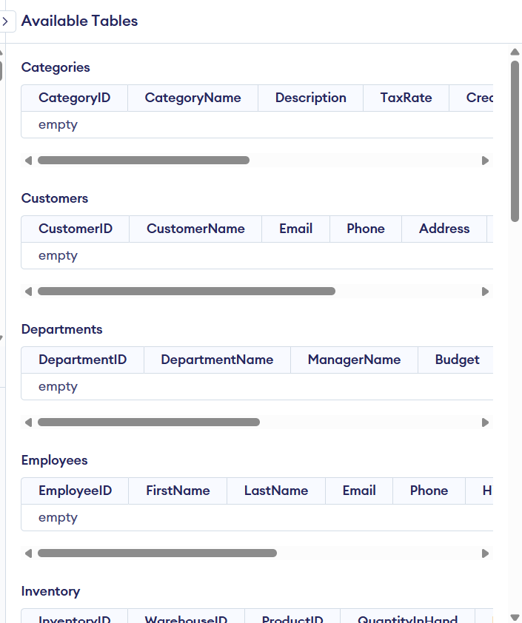
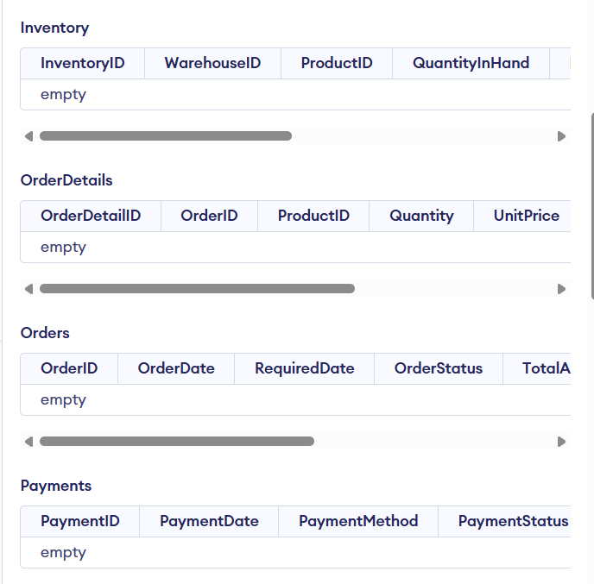
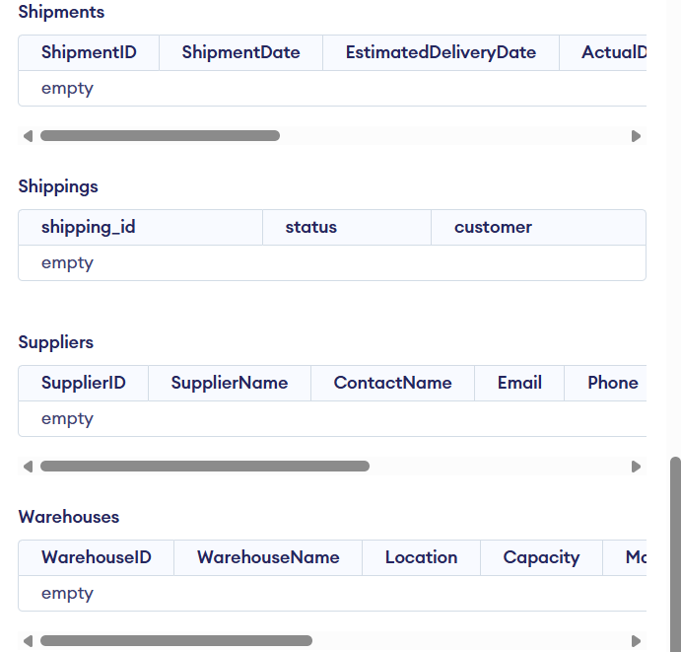

3. Experimental Constraint Testing Report
To guarantee structural integrity, manual errors were forced within an isolated SQL execution stream to observe database engine reactions.
Forced Error Vector | Targeted Constraint | Engine System Error String Output | Final Status
Deleting Category row | RESTRICT | ERROR: update or delete on table 'categories' violates foreign key constraint 'fk_prod_cat' on table 'products' | PASS
Orphan Product Entry | FOREIGN KEY | ERROR: insert or update on table 'products' violates foreign key constraint 'fk_prod_cat' | PASS
ID Shift on Department | ON UPDATE CASCADE | No error message returned. 15 records in child table 'Employees' automatically synchronized values. | PASS
Non-Unique Email Insert | UNIQUE | ERROR: duplicate key value violates unique constraint 'customers_email_key' | PASS
Stripping Customer Name | NOT NULL | ERROR: null value in column 'customername' violates not-null constraint | PASS

4. Analytical Query Performance & Outputs
This section lists the exact production SQL statements used to derive business analytics from the operational baseline data.
Query 6.1: Customers Without Active Orders
sql
SELECT c.CustomerID, c.CustomerName, c.Email
FROM Customers c
LEFT JOIN Orders o ON c.CustomerID = o.CustomerID
WHERE o.OrderID IS NULL;

Use code with caution.
- Expected Behavior: Isolates inactive accounts cleanly by mapping NULL state markers across the outer table boundary.
Query 6.2: Products Maintained by Multiple Suppliers
sql
SELECT ps.ProductID, p.ProductName, COUNT(ps.SupplierID) AS SupplierCount
FROM ProductSuppliers ps
JOIN Products p ON ps.ProductID = p.ProductID
GROUP BY ps.ProductID, p.ProductName
HAVING COUNT(ps.SupplierID) > 1;

Use code with caution.
- Expected Behavior: Aggregates cross-supplier fulfillment paths to pinpoint sourcing redundancies.
Query 6.3: Open Orders Labeled as Unpaid
sql
SELECT o.OrderID, o.OrderDate, c.CustomerName, p.PaymentStatus, o.TotalAmount
FROM Orders o
JOIN Payments p ON o.OrderID = p.OrderID
JOIN Customers c ON o.CustomerID = c.CustomerID
WHERE p.PaymentStatus = 'Unpaid';

Use code with caution.
- Expected Behavior: Filters accounting ledgers for immediate revenue recovery collections.
Query 6.5: Warehouse Nodes Running Under Thresholds
sql
SELECT DISTINCT w.WarehouseID, w.WarehouseName, w.Location, p.ProductName, i.QuantityInHand
FROM Warehouses w
JOIN Inventory i ON w.WarehouseID = i.WarehouseID
JOIN Products p ON i.ProductID = p.ProductID
WHERE i.QuantityInHand < 10;

Use code with caution.
- Expected Behavior: Generates real-time procurement alerts across physical stock hubs.
Query 6.9: Top Five Luxury Products Matrix
sql
SELECT ProductID, ProductName, Price, Stock
FROM Products
ORDER BY Price DESC
LIMIT 5;

Use code with caution.
- Expected Behavior: Fast sorting sequence highlighting inventory items with high capital value.
Query 6.10: Tracking Major Logistics Delays
sql
SELECT ShipmentID, OrderID, CarrierName, TrackingNumber, EstimatedDeliveryDate, ActualDeliveryDate,
(ActualDeliveryDate - EstimatedDeliveryDate) AS DaysDelayed
FROM Shipments
WHERE ActualDeliveryDate > EstimatedDeliveryDate
AND (ActualDeliveryDate - EstimatedDeliveryDate) > 5;

Use code with caution.
- Expected Behavior: Exposes carrier bottlenecks by highlighting shipments delayed by more than five days.

